

|  |  |
| --- | --- |
| **NAME** | **AARYAN SINHA** |
| **ROLL NUMBER** | **20051796** |
| **SECTION** | **CSE-17** |
| **COURSE** | **WEB TECHNOLOGY** |
| **ASSIGNMENT TOPIC** | **JAVA CODES** |
| **ASSIGNMENT NUMBER** | **5** |

* **QUESTION 1- CHECK EVEN/ODD**

import java.util.Scanner;

class q_1_even_odd

{

public static void main (String [] args)

{

// to check a number is even or odd

System.out.println("Checking if even or odd");

System.out.println("Enter a number");

Scanner input = new Scanner(System.in);

int num= input.nextInt();

System.out.println("You entered " +num);

if(num%2==0)

{

System.out.println("This is an Even number");

}

else

System.out.println("This is an Odd number");

}

}

**OUTPUT -1**

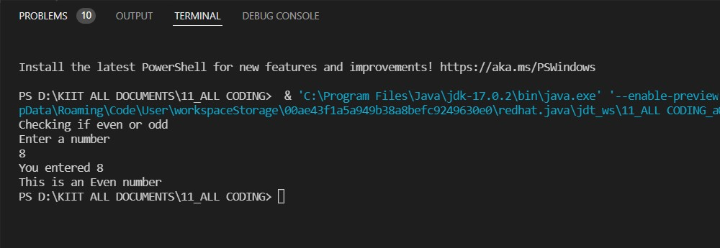

* **QUESTION 2- AREA AND PERIMETER OF A RECTANGLE**

import java.util.Scanner;

public class q_2_ar_peri_rect

{

public static void main (String[] args)

{

int l,b;

// to calculate area and peri for rectangle

System.out.println("Enter the value for length");

Scanner input= new Scanner(System.in);

l = input.nextInt();

System.out.println("Enter the value for breadth");

b=input.nextInt();

int area;

area = l*b;

System.out.println("Area of rectangle is " + area);

int peri;

peri = 2*(l+b);

System.out.println("Perimeter of Rectangle is " + peri);

}

}

**OUTPUT -2**

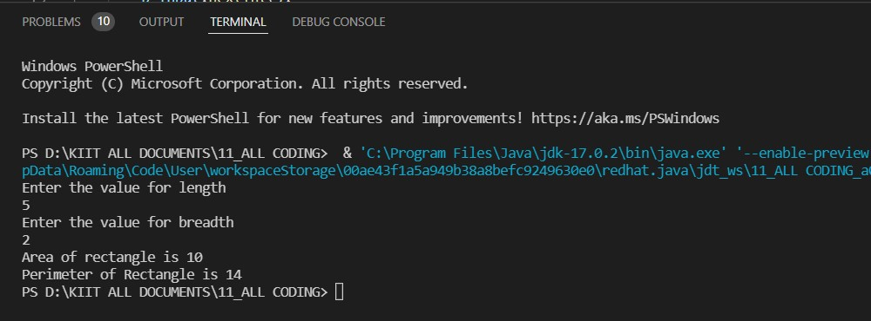

* **QUESTION 3 -FACTORIAL OF AN INTEGER**

import java.util.Scanner;

public class q_3_fact

{

public static void main (String[] args)

{

System.out.println("Enter a number: ");

int fact=1;

int num;

Scanner input = new Scanner(System.in);

num = input.nextInt();

while(num>0)

{

fact= fact*num--;

}

System.out.print("The factorial of "+num);

System.out.println("is coming out to be "+fact);

}

}

**OUTPUT -3**

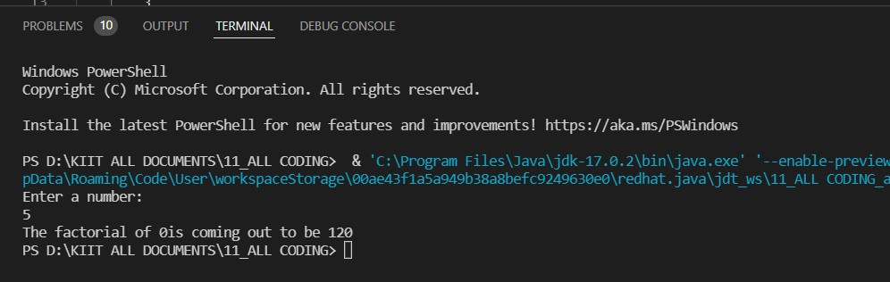

* **QUESTION 4 ROOTS OF A QUADRATIC EQUATION**

import java.util.Scanner;

public class q_4_roots_quad {

public static void main(String args[])

{

Scanner input= new Scanner(System.in);

float x, z, y;

double root1, root2, imaginary, disc;

System.out.println("Enter three values for the Quadratic Equation : ");

x=input.nextInt();

z=input.nextInt();

y=input.nextInt();

disc= (z * z) - (4 *x *y);

if(disc > 0)

{

root1 = (-z + Math.pow(disc, 0.5)) / (2 * x);

root2 = (-z - Math.pow(disc, 0.5)) / (2 * x);

System.out.println("Two Real Roots Exists: ="+root1+"and"+root2);

}

else if(disc == 0)

{

root1 = root2 = -z / (2 * x);

System.out.println("Two Distinct Real Roots Exists: ="+root1);

}

else if(disc < 0)

{ System.out.println("Imaginary Roots");

}

}

}

**OUTPUT 4**

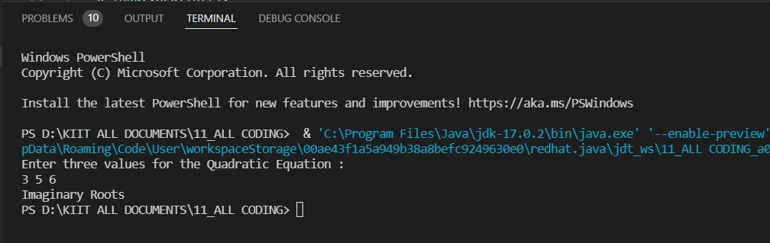

* **QUESTION 5- TEMPERATURE CONVERSION**

import java.util.Scanner;

public class q_5_temp_conv

{

public static void main(String args[])

{ double farh, cel;

Scanner input = new Scanner(System.in);

System.out.println("Choose type of conversion \n 1.Fahrenheit to Celsius\n 2.Celsius to Fahrenheit");

int ch = input.nextInt();

switch (ch)

{

case 1: System.out.println("Enter Fahrenheit temperature");

farh = input.nextDouble();

cel = (farh - 32) * 5 / 9;

System.out.println("Celsius temperature is = " + cel);

break;

case 2: System.out.println("Enter Celsius temperature");

cel = input.nextDouble();

farh = ((9 * cel) / 5) + 32;

System.out.println("Fahrenheit temperature is = " + farh);

break;

default: System.out.println("please choose valid choice");

}

}

}

**OUTPUT**

**1)FARH TO CEL**

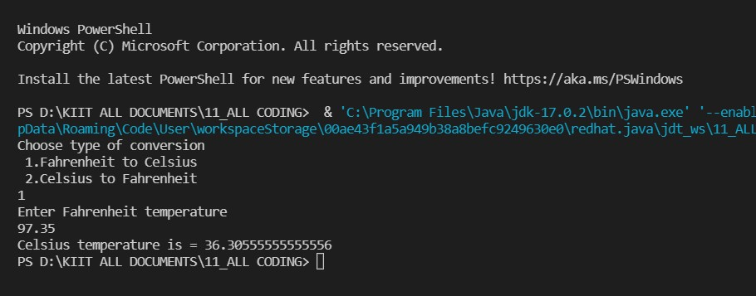

1. **CEL TO FARH**

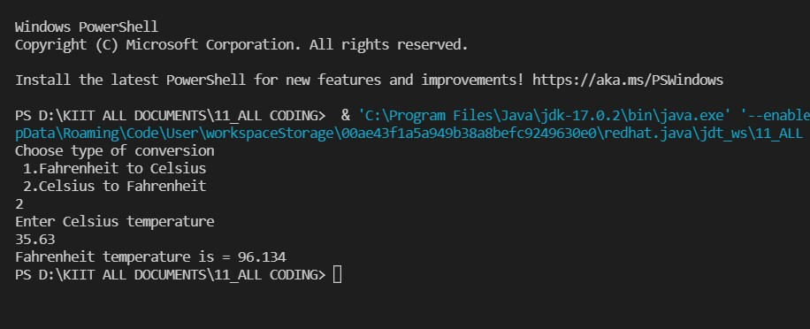

* **QUESTION 6- SECONDS TO HOURS,MINUTES AND SECONDS**

import java.util.Scanner;

public class q_6_sec_to_hr_min_sec

{

public static void main(String[] args)

{

System.out.println("Time conversion");

System.out.println("Enter the value for seconds");

int sec1,hr,min,sec2;

Scanner input = new Scanner(System.in);

sec1=input.nextInt();

hr=sec1/3600;

min=(sec1%3600)/60;

sec2=sec1%60;

System.out.println("The convserion of seconds to hr:min:sec is ");

System.out.println(hr+":"+min+":"+sec2);

}

}

**OUTPUT**

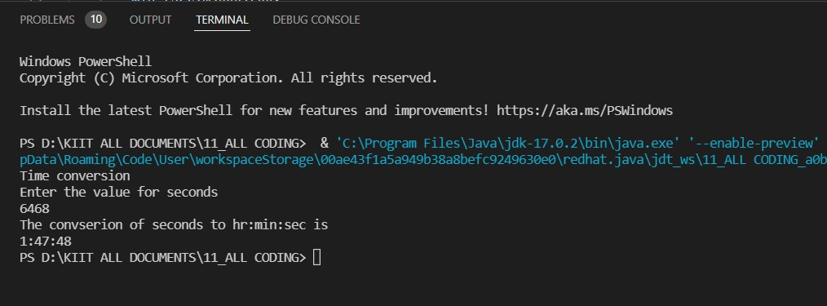

* **QUESTION 7- DECIMAL TO BINARY**

import java.util.Scanner;

public class q_7_dec_bina

{

public static void main(String args[]){

Scanner input=new Scanner(System.in);

int n;

int[] bnum= new int[1000];

int i = 0;

System.out.println("Enter the number :");

n=input.nextInt();

while (n > 0)

{

bnum[i] = n % 2;

n = n / 2;

i++;

}

for (int j = i - 1; j >= 0; j--)

System.out.print(bnum[j]);

}

}

**OUTPUT**

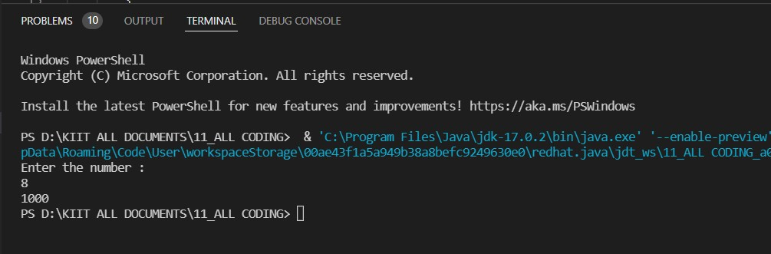

* **QUESTION 8- SUM OF DIGITS OF AN INTEGER**

import java.util.Scanner;

public class q_8_sum_dig

{

public static void main(String[] args)

{

System.out.println("Enter a number");

int num;

int digit; //number to store last digit

int sum =0; // number to store sum of digit

Scanner input = new Scanner(System.in);

num = input.nextInt();

while(num>0)

{

digit=num%10;

sum+=digit;

num=num/10;

}

System.out.println("The sum of digits are: " + sum);

}

}

**OUTPUT**

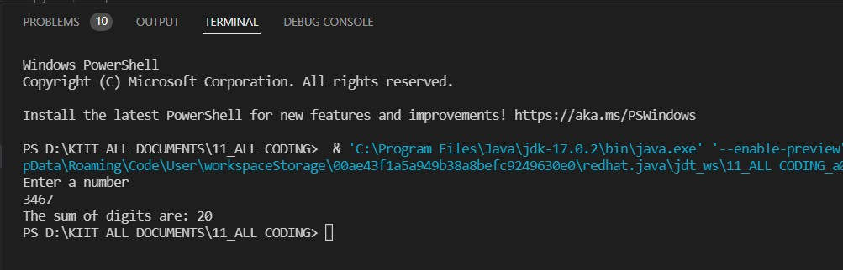

* **QUESTION 9- CHECK PRIME**

import java.util.Scanner;

public class q_9_prime_check {

public static void main(String[] args)

{

System.out.println("Enter a number");

int num;

int isPrime =1;

Scanner input = new Scanner(System.in);

num=input.nextInt();

if(num == 0 || num==1)

{

System.out.println("Not a prime number");

}

for(int i=2; i*i<num;i++)

{

if(num%i==0)

{

isPrime=0;

}

}

if(isPrime==1)

{

System.out.println("The number is prime number");

}

else

{

System.out.println("The number is not prime number");

}

}

}

**OUTPUT**

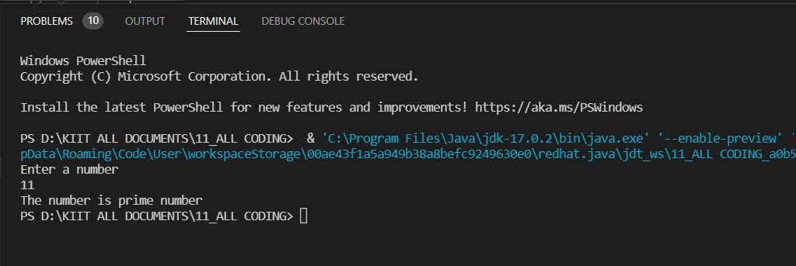

**END**